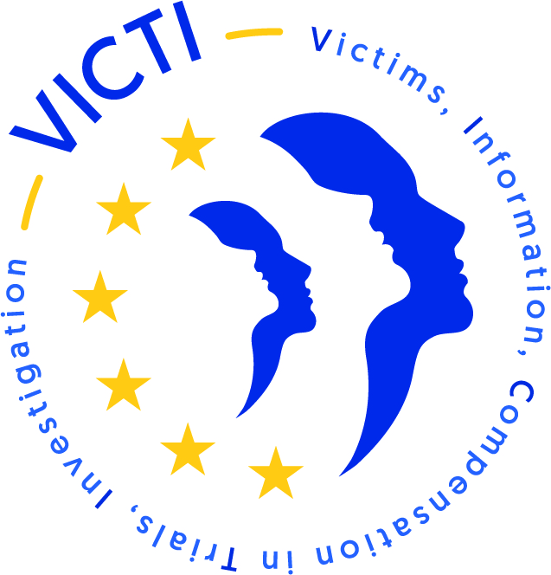

CALL FOR EXPERTS
THE PLACE OF VICTIMS IN CRIMINAL PROCEEDINGS WITH A SUBSTANTIAL
NUMBER OF VICTIMS
Activities
- Seminar on the "the place of victims in criminal proceedings with a substantial number of victims: the compensation" on 22, 23 and 24 November 2023 (2.5 days) – at the Scuola superiore della magistratura - SSM, Napoli, Italy

Directive 2012/29/EU establishing minimum standards on the rights, support and protection of victims of crime was published in the Official Journal of the European Union on 25 October 2012.
The Directive's aim was to establish standards on the rights, support and protection of victims of crime. It guarantees victims four series of rights within the European Union: information, support, protection, participation in criminal proceedings.
In the face of the multiplication of proceedings referred to as "exceptional" with regard to the number of victims concerned and the scale of the investigations to be carried out, legal professionals are attempting to reconcile the effectiveness of the criminal procedure with victims' rights. This is a considerable challenge insofar as the application of the rules of criminal procedure is difficult to reconcile with victims' rights in the case of these "exceptional" proceedings.
This project is funded by the European Commission. It offers legal professionals in European countries the chance to discuss the practices implemented to guarantee victims' rights in these proceedings and to exchange views on how to promote and duplicate practices that have proven successful.
Several inter-professional activities and training sessions are being organised in 2022 and 2023. Participants will be provided with "good practices" technical information sheets (in French, English, Spanish and Italian) after each activity.
The project is run by the French National School for the Judiciary (ENM) in partnership with the Italian school for the judiciary (Scuola superiore della magistratura - SSM), the Belgian judicial training institute (IFJ-IGO), the Spanish judges' training school (Consejo General del Poder Judicial - CGPJ), the Spanish prosecutors' training school (Centro de Estudios Jurídicos - CEJ), the Romanian National Institute of the Judiciary (Institutul National Al Magistraturii - NIM), the Netherlands national judicial training school (Studiecentrum Rechtsplegin - SSR), the Delegation of the Bars of France (DBF) and the European Network on Victims' Rights (ENVR).
****

Practical information
Objectives of the training: To ensure effective implementation of the 2012 Directive and the minimum set of victims' rights in so-called exceptional proceedings, to exchange good practices between European judges, prosecutors and other judicial professionals concerning these proceedings that are difficult to deal with due to the numbers of victims and the scale of the investigations, to harmonise and improve respect for victims' rights during these "exceptional" proceedings, especially for the compensation phase, for this seminar.
Format: The seminar will take place in person, in Napoli, and will alternate presentations, case studies and restitution.
Dates and venue:
- 22, 23 and 24 November 2023 (2.5 days)
- Scuola superiore della magistratura - SSM, Napoli, Italy

Languages: English, French and Italian (simultaneous interpreting for plenary only) – managing English and/or French for workshops is mandatory.

Participants: 70 participants (judges, prosecutors, specialised assistants, lawyers, clerks, experts, support victims’ association, members of the European Network on Victims' Rights (ENVR))

Target countries: Belgium, France, Italy, the Netherlands, Spain, Romania and every country represented by the European Network on Victims' Rights (ENVR).

***

Expected from the experts
Content:
On 22/11 – 30-minutes presentation and 30-minutes exchange with the participants
Objective: exchange best practice between magistrates and European justice professionals on compensation procedures in cases of multiple victims, which are difficult tò understand due to the number of victims and their nationality.

On 23/11 – to co-lead a workshop of 15 participants and study a factice case. The case is drafted by the scientific committee members of the project. The experts mobilised to co-lead workshops will have to familiarise themselves with the case study.
Objective: identify the issues involved in compensating victims in "exceptional" proceedings, particularly with regard to victims' rights: information, communication, support, protection and access to justice, with the aim of maintaining a high level of respect for victims' rights in accordance with the requirements of Directive 2012/29/EU.

Profile:

The expert should have experience in “exceptional” damage assessment on one of the following topics:
- Terrorism
- Collective accidents
- Serial claims (healthcare)

The expert can be a member of the judiciary, justice professionals or a medical expert.

Coverage of expenses:

The ENM will book accommodation and return trip for the experts.
After the seminar and after completing an expenses form, the expert will be reimbursed for the following costs:
- 98 euros per day for meals and local transport (metro tickets, taxis, buses, VTC) – 3 days as a maximum;

Expertise fees:

Activities | Days
Preparation of seminar 3 | 1
Participation to the seminar 3 | 2
TOTAL | 3

Gross rate of hourly fees paid | Number of hourly fees/day | Number of days | Total gross in euros
70 € | 4 | 3 | 840 €

Funded by the European Union Justice Programme
Financé par le programme Justice de l’Union Européenne



The points of view and opinions expressed are those of their authors only and do not necessarily reflect those of the European Union or the ENM. Neither the European Union nor the contracting authority may be held liable for them.

